# Delilha Restó

Delilah Restó is a restaurant web application. This project contains the backend component of the system, which in general is an product catalog and order manager.

## Installation

### HTTP Server and Database

The Delilah Restó system runs with a MySQL database, so the MySQL Database engine must be installed.

1. Install XAMMP
2. Start both Apache and MySQL

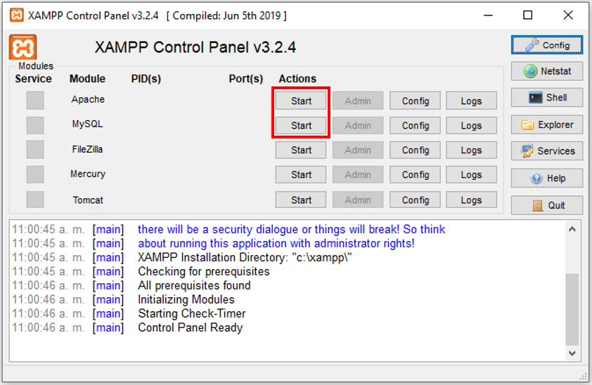

1. Open the MySQL Admin

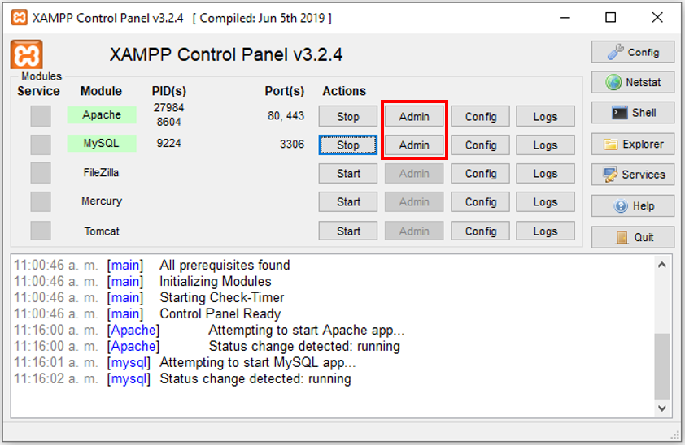

1. Create a new database

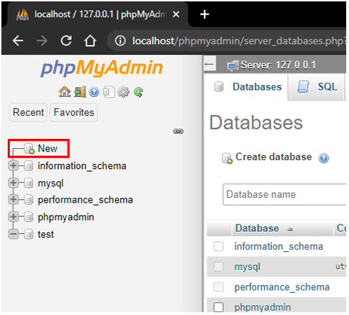

1. Name the new database as “delilah_resto” and click on create

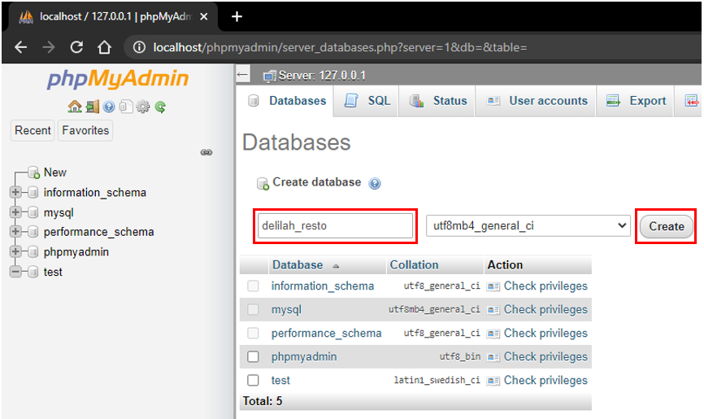

1. Click on “import”

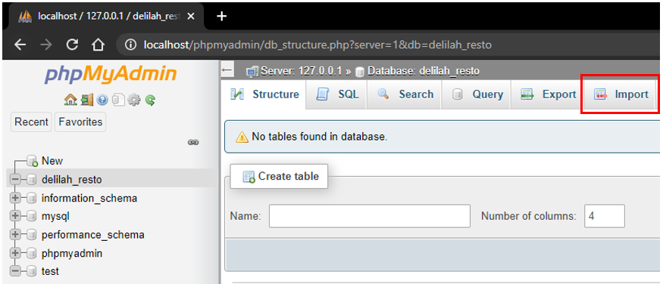

1. Click on select

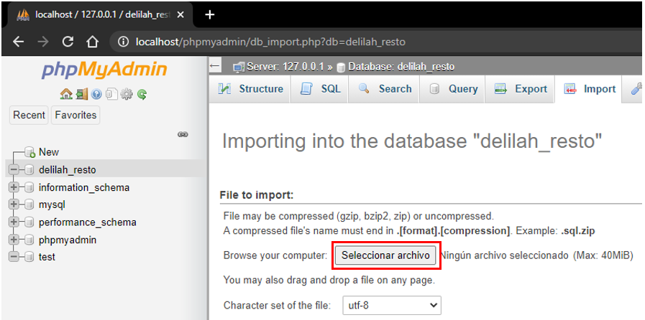

1. Select the “delilah_resto.sql” file attached in the project folder

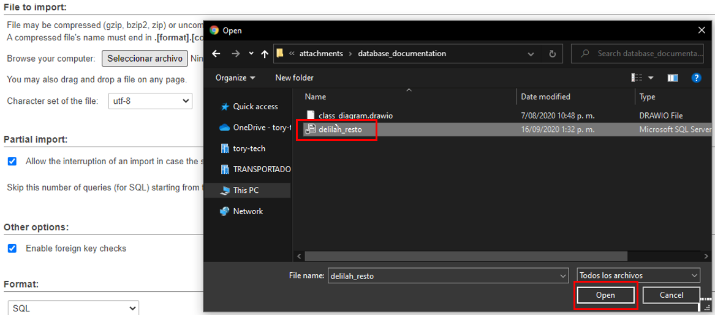

1. Click on “Go”

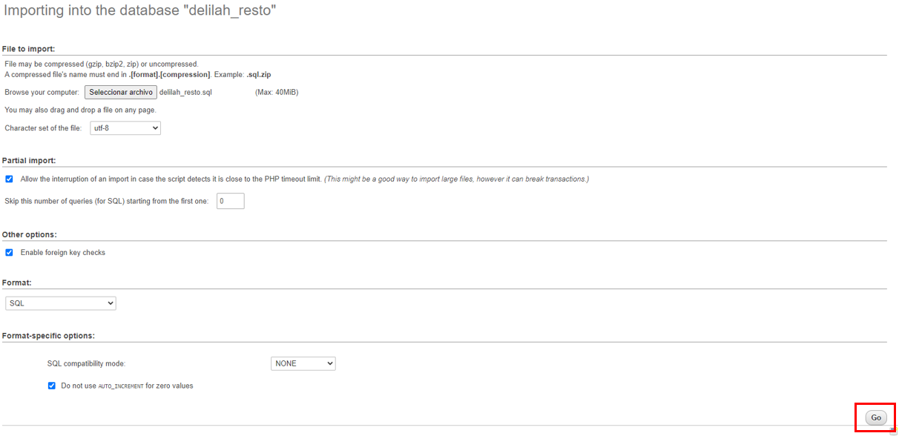

1. The following message should appear as well as the database structure

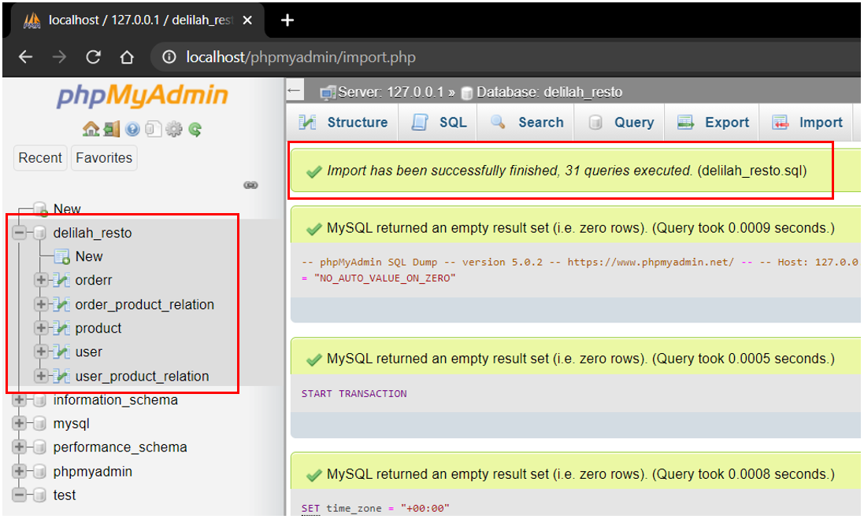

### Express Server

1. Install nodeJS
2. Open a CMD and
3. Run the following command “cd C:\Users\Public\Documents\delilah_resto\routes”. Ensure the path in the command matched the absolute path of the routes folder in your pc.
4. Run the following command “node index.js”
5. The following message should appear



## Usage

In order to know about the use of this API please refer to the .yaml file to see the swagger OpenAPI API file description.

## Testing

Use Postman to test all the endpoints available in the API. All requests have been tested previously so there is a request Postman collection available inside the project folder inside the “attachments” folder, “Delilah Restó.postman_collection.json”.